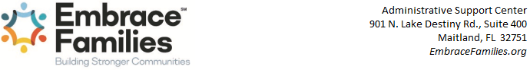
Date:
4/27/2022
Child's Name:
A'ALIYAH FLEMMING
Date of Birth:
4/24/2019
SSN:
827586987
Medicaid #:
9608530067
FSFN Person Id:
107505212
FSFN Case Id:
100572479
Placement Date:
2022-03-24-07.00.00.000000
To Whom It May Concern:
This letter is to certify that Morales Roman, Scherezada, foster parent/caregivers(s) of the above named child who resides at 12286 Sabal Palmetto PL Orlando, FL 328247348, is fully authorized by Embrace Families Community Based Care, Inc., the lead child welfare agency under subcontract with the State of Florida Department of Children and Families, to execute any and all actions necessary for the care, custody and control of the above mentioned child, including consent to ordinary and necessary medical examinations and treatment, access to records, including but not limited to medical, psychological, and psychiatric, and educational, or any action necessary for school enrollment and school activities.
This authorization does not include consent for surgery, general anesthesia, provision of psychotropic medications, or other extraordinary procedures for which a separate court order or informed consent is required by law. Medicaid is available for children placed in out of home care. A delay in Medicaid determination should not result in a delay of the child receiving services. To avoid unnecessary delay, the cost of the service will either be reimbursed retroactively by Medicaid or in the event that the child or service is determined to be Medicaid ineligible reimbursed by Embrace Families Community Based Care with a prior authorization.
If you have questions or require additional information, please contact the Embrace Families Community Based Care Intake & Placement Unit at 321-300-0466.
CMA:
OR-CHS
Unit: 079213-CBCCF CHS ORANGE
CM:
Stenger , Jennifer Marie
Phone: (407) 307-9224
Email: jennifer.stenger@chsfl.org
CMS:
Ziccardi, Stefaine
Phone: (321) 207-8200
Email: stefaine.ziccardi@chsfl.org
Sincerely,
Ashley Bastien, MSW
Intake and Placement Clinical Manager
