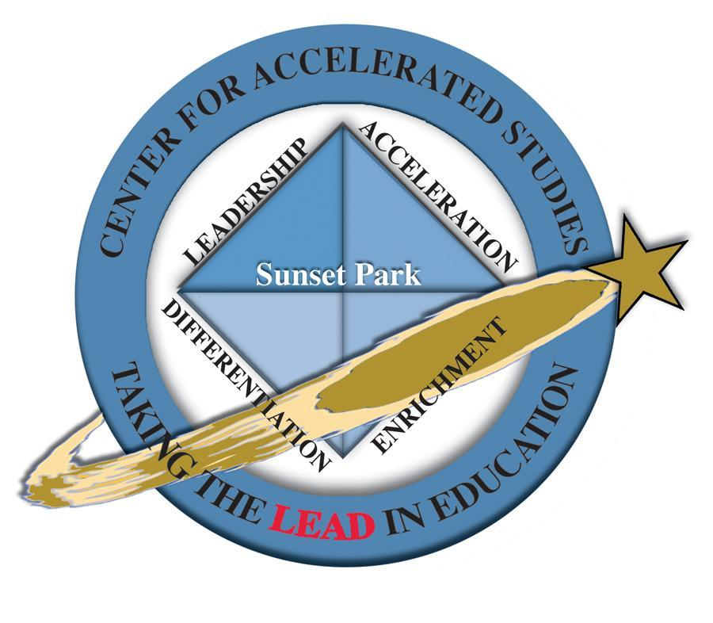 

May 4, 2023

Dear Parent/Guardian,

We are excited to announce in partnership with Clinton College and Moolah Wireless each student at Sunset Park Center for Accelerated Studies is eligible to receive a tablet at the end of the school year. This generous action in collaboration with Clinton and Moolah is part of an initiative to support Sunset Park’s goal of growing readers as well as assisting with having access to the Internet when students are away from school. Each tablet will come loaded with the Kindle application. Within the application, there will be several books loaded for the students to enjoy over the summer. To add more books, you will need to purchase them through the Kindle application (Amazon). There are many books available that are low-cost, or even free. In addition, the students will receive Moolah cash for the books they read and can purchase additional books with the cash they earn. The student tablets are FREE for all students and they are for the students TO KEEP. Please join us in thanking Clinton College and Moolah Wireless for their generosity.

Parents will need to pre register and pick the tablets up at Sunset Park on **Friday, May 19 from 9:00 a.m. to 4:00 p.m.** OR **Monday, May 22 from 8:00 a.m. to 6:00 p.m.** Prior to pick up, please plan to fill out the information below.

Here is the link (and instructions) for you to pre register for the device in advance. [Tablet signup - Moolah Wireless](https://moolahwireless.com/tablet-signup/?agentcode=Clinton%20college) (<https://moolahwireless.com/tablet-signup/?agentcode=Clinton%20college>)

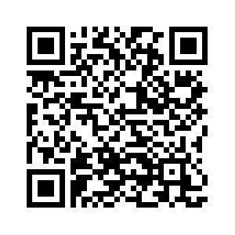

1. Click “Free Lunch” only. (We are a Community Eligibility Provision School and all of our students receive free breakfast and lunch.)
2. Only parents who complete the registration in advance are guaranteed to pick up on the first day.

If you have any questions, please contact me 803 (981-1260).

Sincerely,

Dr. Barnes-Sunset Park Center for Accelerated Studies