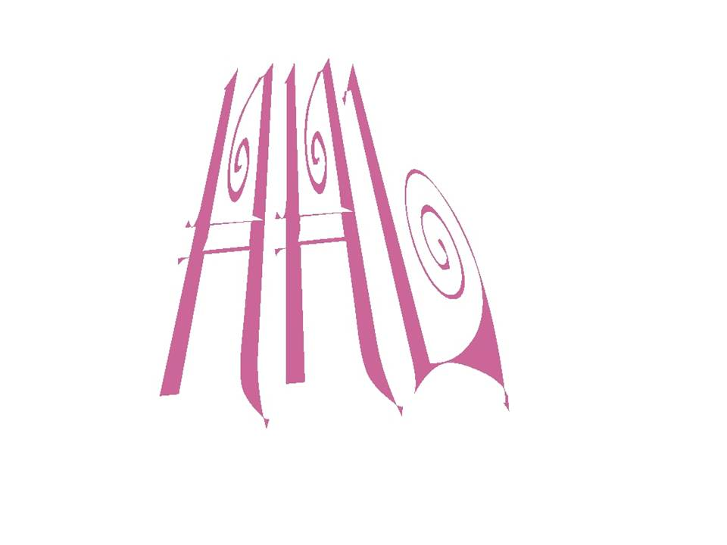**HOWEY HUDSON LOWE FOUNDATION, INC.**

**P.O. BOX 361674, DECATUR, GA 30036-1674**

**770-808-9015 / 770-808-0114**

[**www.howeyhudsonlowe.org**](http://www.howeyhudsonlowe.org)**.** [**hhl@howeyhudsonlowe.org**](mailto:hhl@howeyhudsonlowe.org)**.**

**A Non-Profit 5013c Organization**

Date: ___________

Dear Supporter: _______________________________________

We want to thank you on behalf of the Howey Hudson Lowe Foundation for your support of our yearly efforts to bring joy and happiness, and promote physical health and well being amongst families, children, and individuals in the metro Atlanta area.

Your financial contribution of ___________________________________ certainly helps us to continue to make a difference in so many lives. We look forward to our continued friendship.

Sincerely,

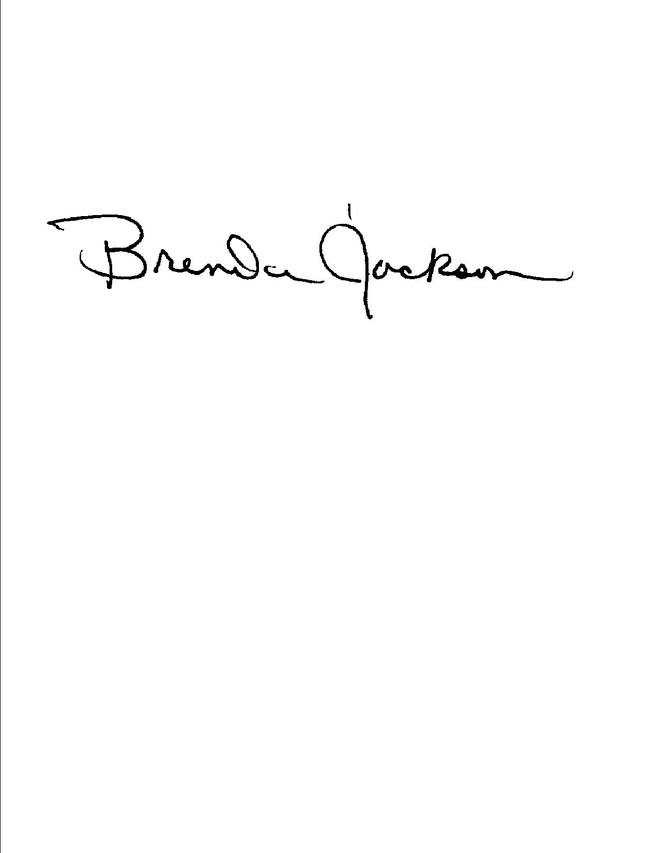

Brenda Jackson

Executive Director