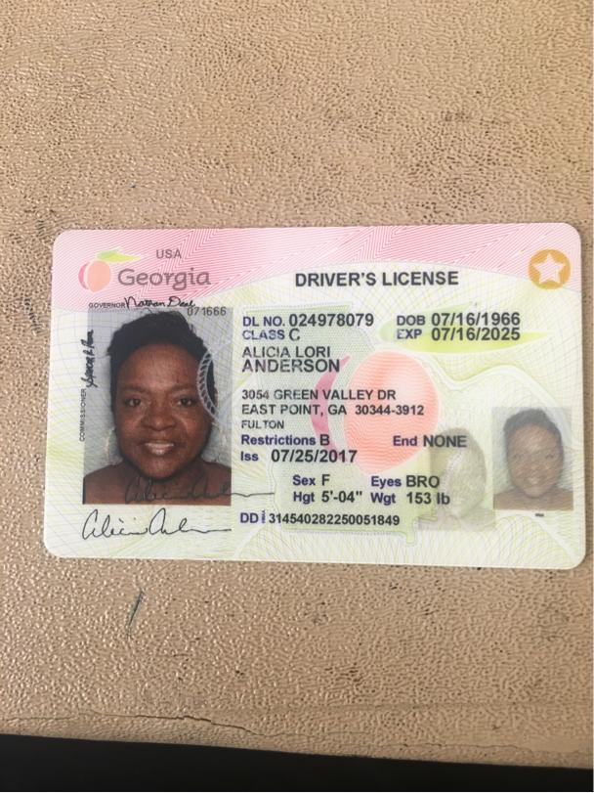

Alicia Anderson - 6970 Cheswick Drive Riverdale, Georgia 30296