Website Changes

- On the Agents admin page where you can see all
  - When an agent adds a support chat, highlight their row until it is viewed and move them to the top. Also send an email to jernise@moolahwireless.com and distribution@moolahwireless.com with the message and who its from
  - Improve the overall look of the messages to look more readable and distinguishable who the admin is and who the agent is
  - Allow images to be uploaded
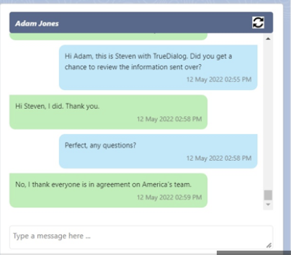

- When you are on tablet-signup under specific agents… and we have enabled the free-lunch … the child info is no longer listed
